

TREES INTRODUCTION

Contents
1) INTRODUCTION 2
2) TERMINOLOGY (1/2) 3
2.1) NODE/VERTEX 3
2.2) EDGE 3
2.3) ROOT NODE 3
2.4) SUB TREE 3
2.5) LEAF 4
2.6) PATH & DISTANCE 4
2.7) FAMILY 5
3) TERMINOLOGY (2/2) 6
3.1) DEGREE 6
3.2) LEVEL 6
3.3) DEPTH 6
3.4) BREADTH 6
3.5) SIZE 6
4) BUILD A TREE (FILE SYSTEM) 8
4.1) NODE CLASS 8
4.2) ROOT NODE CLASS 9
4.3) THE EXECUTION 9
5) BUILD A BETTER FILE SYSTEM 10
5.1) CREATING A ROOT NODE 10
5.2) ADD NEW NODE 11
5.3) REMOVE NODE 12
6) TIME COMPLEXITY 13
7) DFS & BFS 14
7.1) DFS APPROACH 14
7.2) BFS APPROACH 15

1) INTRODUCTION
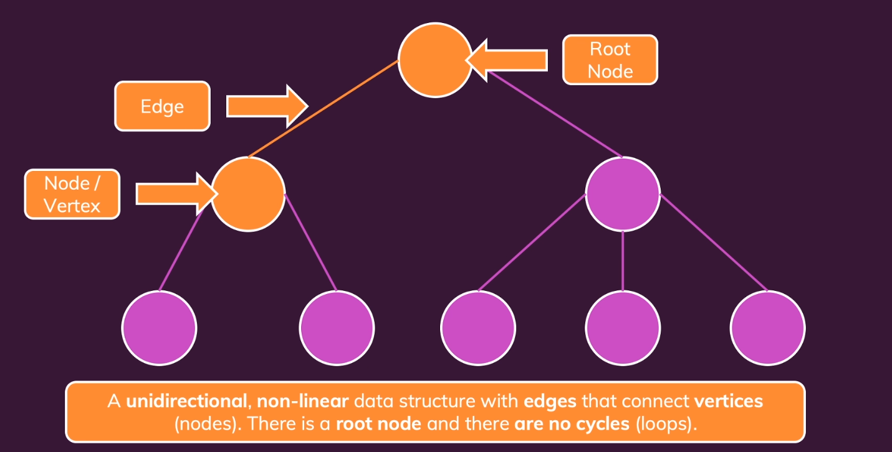

- It has a single root node.
- There are no cycles or loops.
- Examples of tree data structure are: Browser DOM
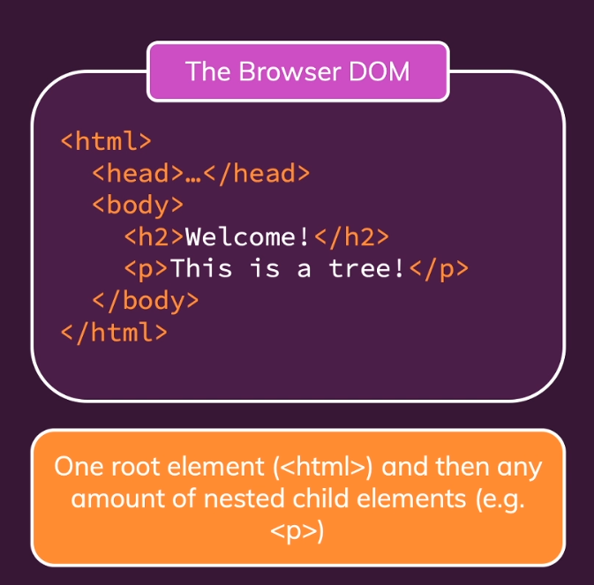

2) TERMINOLOGY (1/2)

2.1) NODE/VERTEX

A structure that contains a value.

2.2) EDGE

The connection between 2 nodes.

2.3) ROOT NODE

The topmost node in the tree.

2.4) SUB TREE

A nested tree, i.e., sub tree root node is not main tree root node.
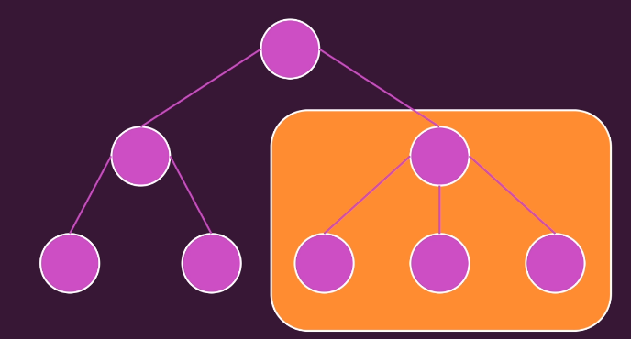

2.5) LEAF

It’s a node without any child nodes (sub tree)
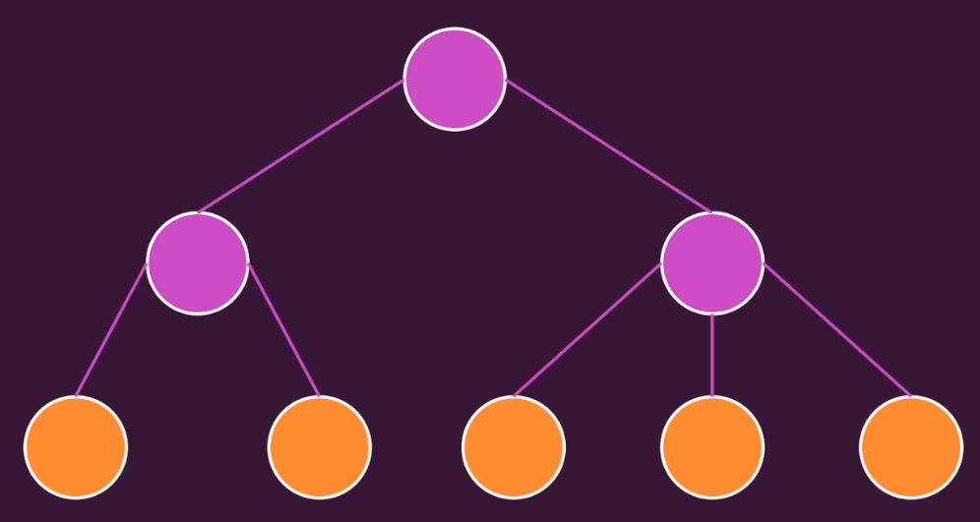

2.6) PATH & DISTANCE

Path: Sequence of nodes and edges that connects two nodes.
Distance: Number of edges between 2 nodes.
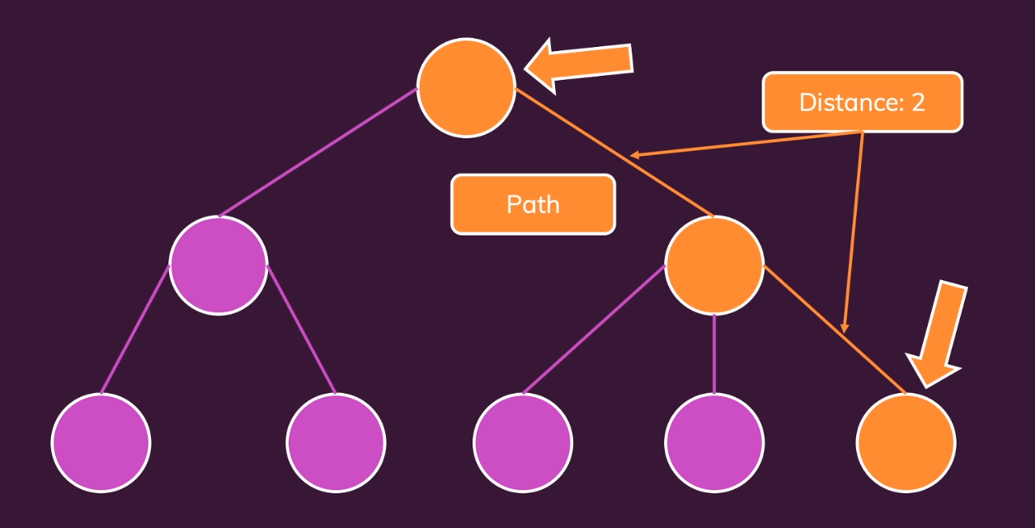

2.7) FAMILY

Parent/Child: Two directly connected nodes, parent is above child node.
Ancestor/Descendant: Two nodes that are connected by multiple parent child paths.
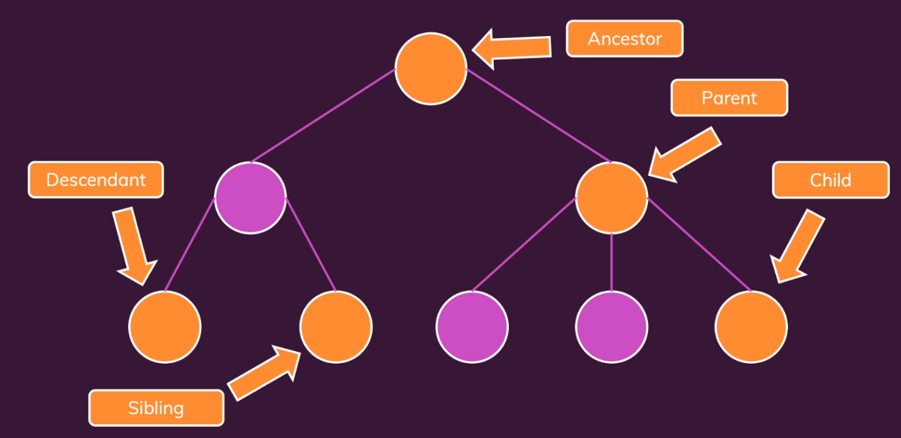
Sibling: Two nodes with the same parent.

3) TERMINOLOGY (2/2)

3.1) DEGREE

Number of child nodes of a given node.

3.2) LEVEL

Distance between a node and a root node.

3.3) DEPTH

Maximum level in a tree. This describes how much vertical space we need.

3.4) BREADTH

The number of leaves in a tree. This describes how broad the tree is. This describes how much horizontal space we need.

3.5) SIZE

Total number of nodes in a tree.

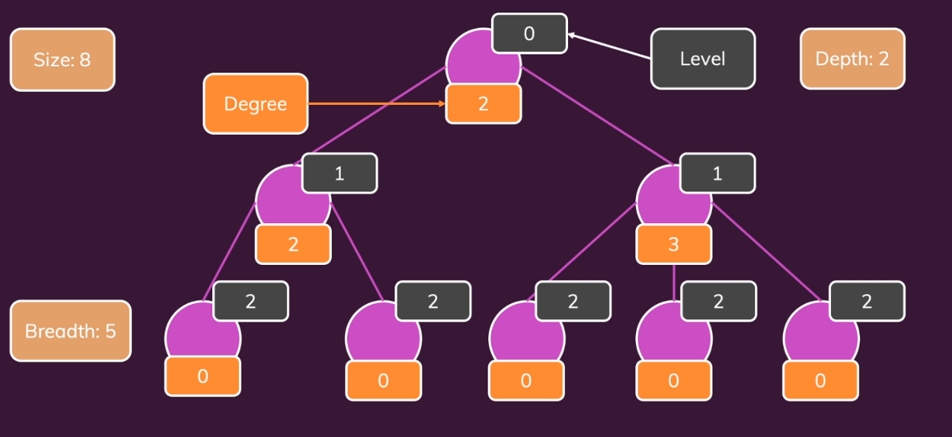
The example for all above is as below:

4) BUILD A TREE (FILE SYSTEM)

Let’s build a file directory.

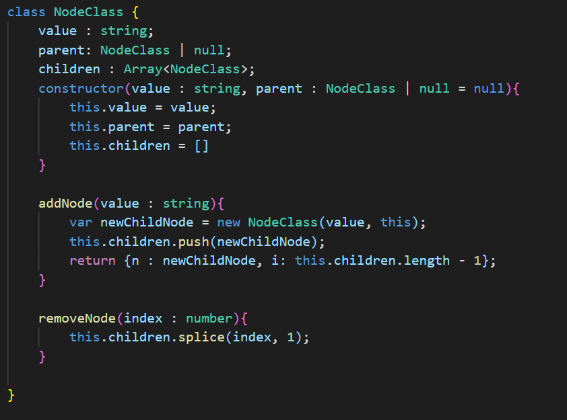
4.1) NODE CLASS

- In every node, we have its parent, children and value.
- We are storing all the children in an array (specific to the particular node alone).
- When we add a node, we are creating a new node and storing in the children and so on. We return the child node and index after creating a new node.
- So, we get a mighty tree, with parents and children.
- While removing a node, we pass the index and value gets spliced.

4.2) ROOT NODE CLASS
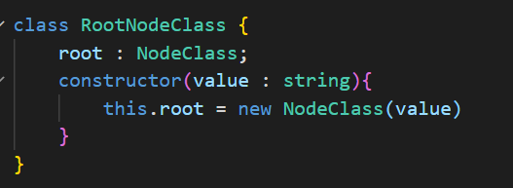

- Here, we are passing the value alone to the main node class in previous section.
- Root node’s parent is null. Hence, we aren’t passing any parent info.

4.3) THE EXECUTION
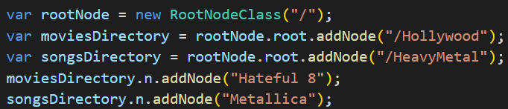

- Self-explanatory.

5) BUILD A BETTER FILE SYSTEM

- The previous one is great, what if I want to give the path so that it creates nodes of it’s own. Let’s try it out:

5.1) CREATING A ROOT NODE
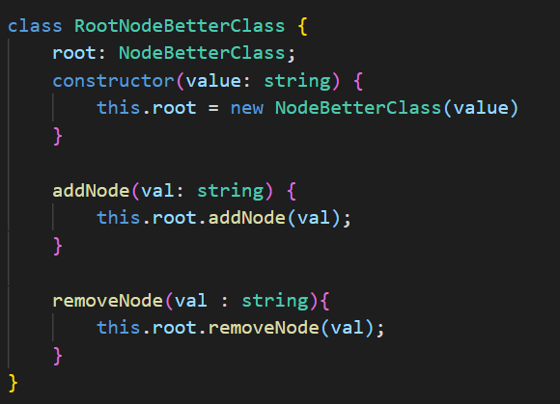

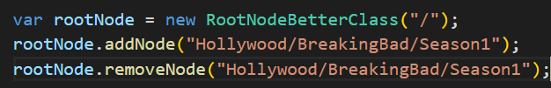
- We have addNode and removeNode within the root node definition itself. This makes us to call addNode function on basic node functionality.

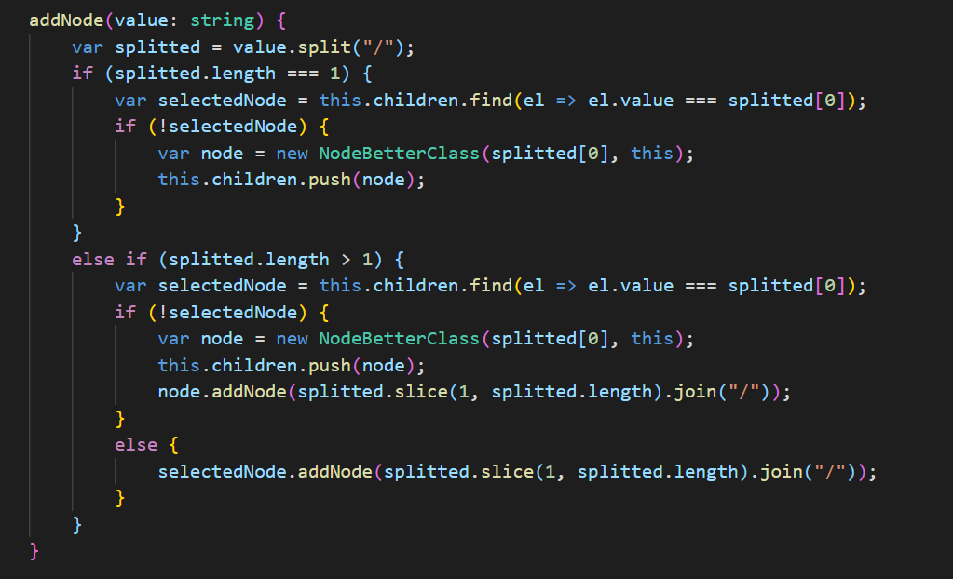
5.2) ADD NEW NODE

- We are using recursion to do so.
- We are not adding a node if it’s already existing.

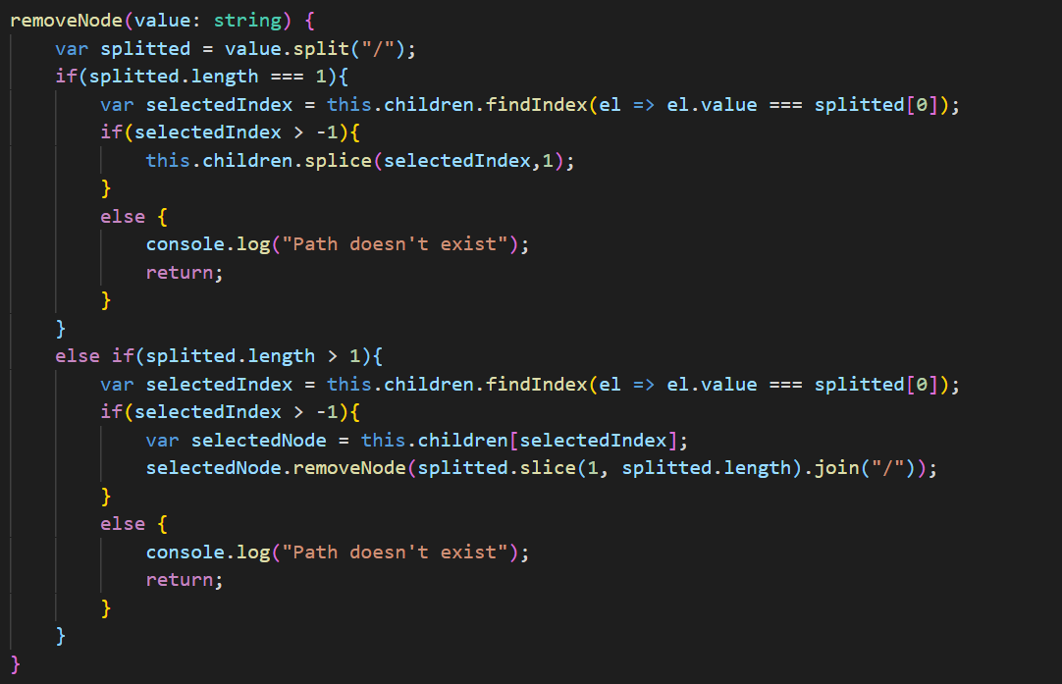
5.3) REMOVE NODE

- We are using recursion to do so.
- We are not deleting the entire file, but only the final element in the chain. E.g., in "Hollywood/BreakingBad/Season1" we are deleting only Season1 alone.
- We are printing the error if the any element is not present (anything in the chain of nodes)

6) TIME COMPLEXITY
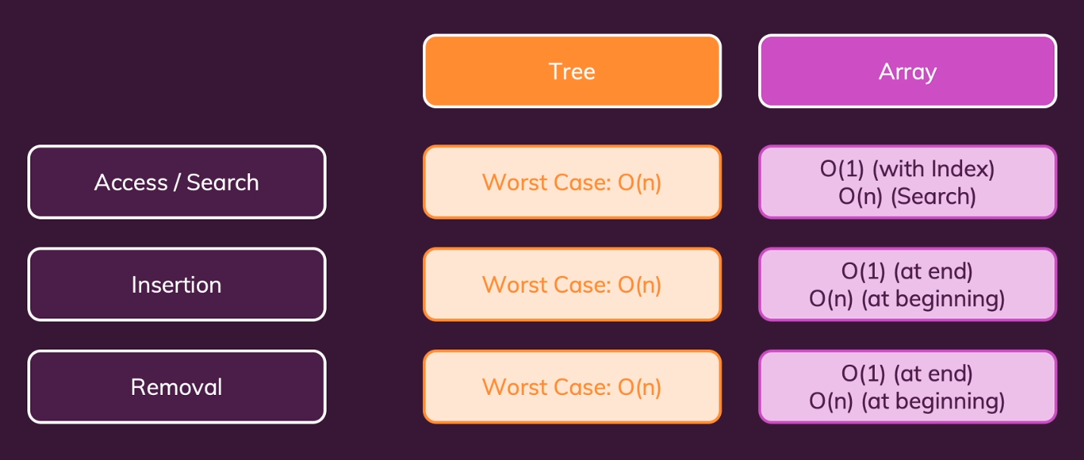

7) DFS & BFS

Searching techniques, we can do with Depth first search or Breadth first search. Say, in the above file system we are supposed to search for a node by it’s value and return it.
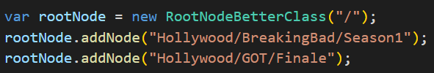
Say we added the nodes as below:

7.1) DFS APPROACH

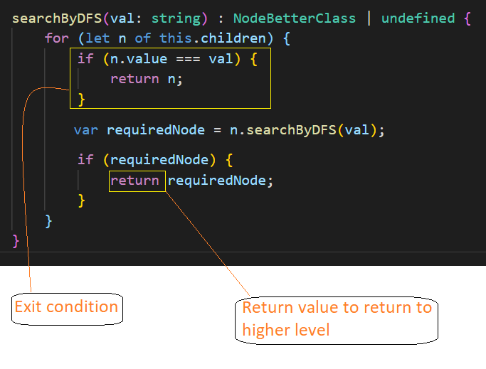
It goes deep into a level and then traces back and goes to next branch.

If we log the output immediately after for loop, see as below:
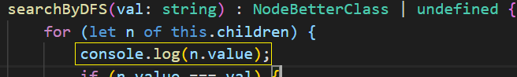

Say we are trying to search Finale, we see the output as below:
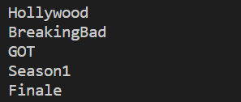

It went deep in one tree and it went to the next one.

7.2) BFS APPROACH

It covers a level goes to the next one, see the below:
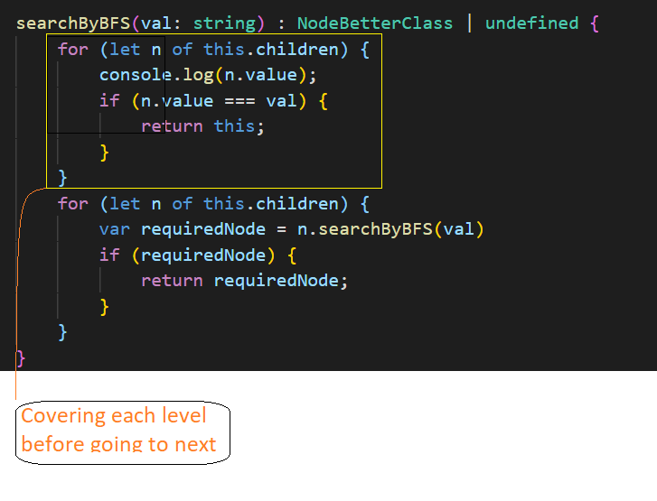

Say we are searching for Finale, we can see the below (console.log after for loop)

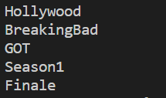

Note: We can choose any one of DFS or BFS as per requirement.

